Table of Contents
Welcome…………………………………………………………………...1
Expectations & Responsibilities…………………………………..….….2
Typical Day at Events……………………………………………………..6
Typical Day at Camp………………………………………………………9
Typical Day with Classes……………...………………………………….13
Behavior Management……………………………………………………15
Safety Awareness…………………………………………………………17
Closing…………………………………………..………………………....18

Appendix
- Age-Appropriate Learning & Conflict Mediation Model
- How to Report Your Service Hours Online
- Know Your Rights & Take Action
- Volunteers Need Breaks Too!

WELCOME
We are very excited that you have applied to be a part of Tualatin Hills Park & Recreation District’s (THPRD) RISE Leadership Program. RISE, which stands for Realizing Interests through Service Experience, is a great opportunity to explore careers in nature education and recreation-oriented professions, while developing your leadership and communications skills. We want you to make the most of this experience through your professional development, increased connectivity to your community and continued engagement in a fun and exciting atmosphere.

You have applied to volunteer with an organization that has been serving local communities for over 60 years. We love what we do, and we are excited that you want to be a part of it!

EXPECTATIONS & RESPONSIBILITIES
We ask you to honor your volunteer commitment to fulfill the role you have accepted. Listed below are some of the important expectations and responsibilities we have for you.

Time Commitment
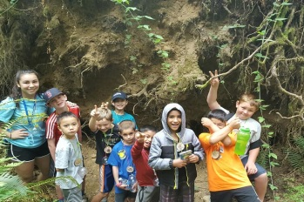
To become a RISE certified volunteer, you are required to volunteer for a minimum of 80 hours over the course of the year. Many RISE participants choose to put in more hours than are required. You will work with your staff supervisor to design a personal volunteer schedule that works for both you and park district staff.

Dependability & Punctuality
Your assignment as a RISE volunteer is an important one. We ask that you be on time for your scheduled shifts. If you are unable to attend a shift or are running late, you must notify your staff supervisor as soon as possible.

Recording Your Volunteer Hours
You are responsible for tracking and recording your volunteer hours. You can do this online, by logging into your Volunteer Account, or by checking in with the lead staff when you arrive for your volunteer shift. Check the appendix for a cheat sheet on how to enter your hours online.

Breaks & Lunch
Breaks are provided to promote safety and productivity, while also meeting legal requirements. If you need a break, let staff know, so they can provide you with breaks when needed. Just like staff, you will receive at least one 15-minute break during each 4-hour block worked, as well as a 30-minute lunch break during a full day of service.

Professionalism & Customer Service
Although your job as a RISE Leader is voluntary, the commitment is professional. We expect you to maintain an attitude of mutual respect, flexibility, and a willingness to follow instructions provided by staff, so you can take advantage of learning new skills. Here are some tips that will help you maintain a professional demeanor:
- Communicate with your colleagues and supervisor! Concerns or issues need to be addressed and openly discussed with the staff.
- Take initiative when you see something that needs to be done! Don’t expect someone else to do it.
- Do your job and have fun doing it. You’re working with the park district to provide amazing recreational opportunities to the public, so demonstrate an upbeat attitude and professional behavior.
- Accept the rules, as there’s likely a good reason for them.
- If you or a patron gets injured, notify the nearest staff person onsite immediately.
- You may not always like the people you work with, but you are the only one that needs to know, so treat others with respect.

Communication & Entertainment Devices
The use of cell phones or entertainment devices is not allowed during your volunteer shift. You may check messages and make calls during your scheduled breaks and before/after your shift.

Dress Code, ID Badge & Personal Hygiene
Casual dress, such as jeans and shorts, is acceptable. Your RISE t-shirt, volunteer ID badge and closed-toe shoes must be worn while volunteering, the only exception to this is if you are volunteering in or around a pool. Clothing with inappropriate language or pictures is not allowed. You are expected to be well-groomed and to pay attention to personal hygiene when volunteering.

Confidential Information
Information concerning program participants is always personal in nature and may be discussed only with those directly involved in the program. (Ex: Don’t share information or photos on social media sites.) Information about the park district’s employees and volunteers is also of a confidential nature and should not be discussed with unauthorized people.

Personal Information
You should not share personal information with program participants. (Ex: Campers don’t need to know who is dating whom or anything else that may be going on in your personal life.) Personal issues distract from the reason people come to district programs and events.
Diversity, Equity, Inclusion & Access (DEIA)
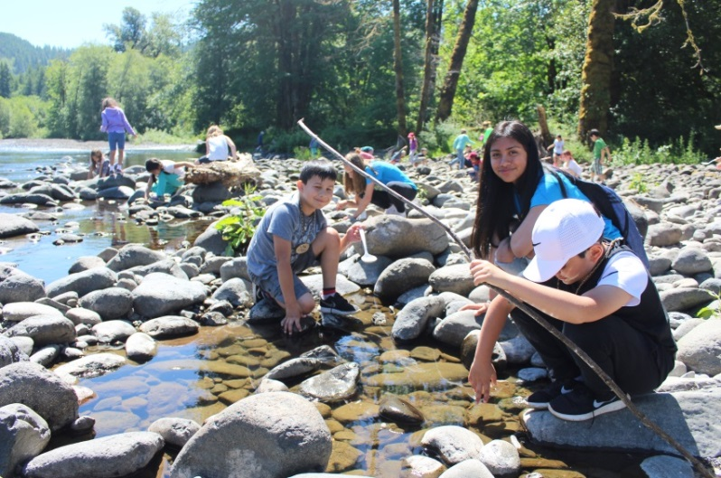
The district provides all individuals the opportunity to play, learn, and explore. As a volunteer, you can help us further the district's mission, by supporting an inclusive culture. The district is actively working to remove barriers that might prevent community members from participating in programs, as well as providing a diverse selection of programs to our patrons. Additionally, the district is actively working on creating spaces to demonstrate solidarity for social and racial justice. Focusing on serving and connecting with traditionally underrepresented communities, including Black, Indigenous, and People of Color (BIPOC) communities.

Volunteer Benefits
As a RISE volunteer, you can gain valuable work experience and skills that will help you build your resume and strengthen college applications. Once you successfully complete the program, you will be certified, earning you the right to include ‘RISE Youth Leader’ in your work history. You will have the opportunity to develop professional relationships with staff, providing you the opportunity to obtain positive recommendations. You can also use your RISE service hours to meet your school community service requirements. For more information on this, contact your school advisor or counselor.

Employment Opportunities
Volunteering does not ensure future employment at THPRD, but it is a great way to build your professional skills and show our staff that you are interested and have the potential to apply for open positions in the future. Check out available THPRD jobs are posted on our website at governmentjobs.com/careers/thprd.
Anti-Harassment & Anti-Discrimination Policy
All THPRD employees and volunteers are responsible for creating a workplace that is free of violence and harassment. This means that you are also protected by the district’s policy against harassment, discrimination, and retaliation. If you experience or observe harassment or discrimination notify your supervisor immediately.
Harassing and discriminatory conduct includes but isn’t limited to:
- Unwelcome physical contact;
- Insults or comments;
- Threatening or intimidating acts;
- Jokes; and/or
- Written or graphic material
based on gender, gender identity, race, ethnicity, national origin, age, ability level, or any other protected characteristic.
Sexual harassment includes but isn’t limited to:
- Unwelcome physical contact;
- Threats or offers in exchange for sexual contact;
- Obscene comments or innuendo; and/or
- Gestures & eye contact.
If you experience or observe harassment, discrimination, or retaliation, tell someone! Your report will be investigated, and action will be taken to prevent harassment or discrimination in the future. You can report it to your supervisor, any THPRD supervisor, any of the staff on the Volunteer Services or Human Resources teams. You can also report it confidentially using our Volunteer Incident Report From online at http://www.thprd.org/connect/volunteer.
Other contacts include:
- Melissa Marcum, Volunteer Services Specialist, m.marcum@thprd.org or (503) 619-3941
- THPRD’s Human Resources team, hr@thprd.org, (503) 614-1200
Public Ethics Rules
As a volunteer, you are held to the same standards as staff. Make sure you accurately report your volunteer hours each week. When interacting with program participants, patrons, and staff, avoid talking about politics and religion, as these are not appropriate conversations to have while volunteering. Lastly, we don’t accept gifts from the public.

Drug-free Workplace & Non-smoking Policy
THPRD is a drug-free workplace. Smoking is prohibited on all THPRD properties. We prohibit the possession, consumption and/or distribution of alcohol and drugs while you are volunteering.
Dismissal from Duty
Volunteering is a privilege that you must earn by honoring the values, goals, and procedures of THPRD. THPRD may at any time, for whatever reason, decide to terminate your volunteer position with the organization or make changes to your volunteer assignment(s). If this is necessary, your staff supervisor will provide you with written notice of dismissal.

TYPICAL DAY AT EVENTS
As a RISE Leader, our staff look to you for support to provide a fun, recreational experience for event attendees of all ages. Your day-to-day activities and responsibilities may look a little different, depending on the types of events you sign up to help with. Here is a general idea of what a typical day will be like for you.
Community & Cultural Events
Located at a Variety of District Parks & Facilities (for all ages)
These events provide fun, family-oriented activities for the public and may help build awareness and appreciation for the various cultures represented in our community. Volunteer shifts at these events can range from 2 – 8 hours in length. RISE Leaders would be expected to take the lead with an activity at the event and assist with event setup, as well as cleanup. The structure and your role at these events would typically include:
- Set-up: Jump in to help setup canopies, tables, chairs, activity stations, games, etc. for the event. You may also be asked to help greet and check-in event volunteers who have signed up to help for the day.
- Activities: Assist staff with providing fun, recreational activities at the event. You will be expected to take the lead at an activity station and help direct event attendees as needed. Activities could include, but are not limited to crafts, door prizes, music, nature education, surveys, sports, games, etc.
- Break-down: This is simply the reverse of setup, as you will be helping to pack up stations, games, etc. and put away canopies, tables, and chairs. You may also be asked to thank and sign-out event volunteers who have signed up to help for the day.
Garden Work Parties
Located at any District Community Gardens & Demonstration Gardens
These events provide an opportunity for the public to get fresh air and exercise, while volunteering to improve a local garden with the park district. Volunteers at these events typically help weed, mulch, cleanup and winterize district gardens. As a RISE Leader, your volunteer shift at these events is typically 3 – 4 hours in length. RISE Leaders would be expected to take on a leadership role during the event and assist with event setup, as well as cleanup. The structure and your role at these events would typically include:
- Set-up: Arrive early to help set up for the project by unloading tools and supplies, setting up the check-in area, inspecting the project area for hazards, etc.
- Activities: Assist staff to facilitate a fun and productive volunteer event, which could mean signing in event volunteers as they arrive, providing a brief orientation and safety talk before getting volunteers started, demonstrating how to properly and safely complete activities, chatting with other volunteers, checking in with other volunteers to make sure they are doing well and working safely, providing a reflection activity for volunteers at the end of the event, etc.
- Break-down: Assist staff with project cleanup by cleaning tools, loading tools and project supplies, inspecting the site for anything that was left behind, etc.
Habitat Restoration Projects
Located at a Variety of District Natural Areas
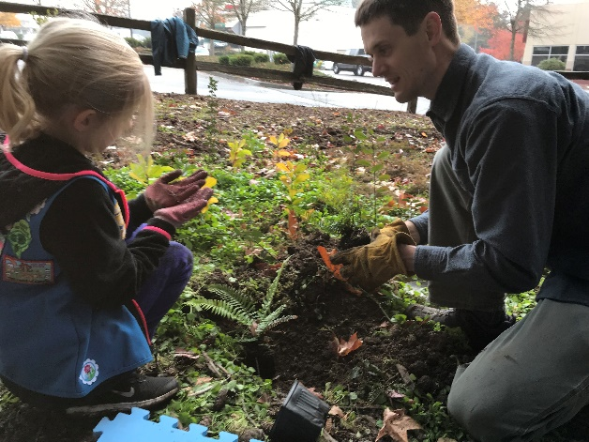
These events provide an opportunity for the public to get fresh air and exercise, while volunteering to improve a local natural area with the park district. Volunteers at these events typically help pick up trash, remove invasive plants and install native plant species throughout a natural area. As a RISE Leader, your volunteer shift at these events is typically 3 – 4 hours in length. RISE Leaders would be expected to take on a leadership role during the event and assist with event setup, as well as cleanup. The structure and your role at these events would typically include:
- Set-up: Arrive early to help set up for the project by unloading tools and supplies, setting up the check-in area, inspecting the project area for hazards, etc.
- Activities: Assist staff to facilitate a fun and productive volunteer event, which could mean signing in event volunteers as they arrive, providing a brief orientation and safety talk before getting volunteers started, demonstrating how to properly and safely complete activities, chatting with other volunteers, checking in with other volunteers to make sure they are doing well and working safely, providing a reflection activity for volunteers at the end of the event, etc.
- Break-down: Assist staff with project cleanup by cleaning tools, loading tools and project supplies, inspecting the site for anything that was left behind, etc.
Nature Mobile & Rec Mobile Events
Located at a Variety of District Events & Community Sites
The Nature Mobile & Rec Mobile take free nature education and recreation programs to convenient locations in the community. If you sign up to volunteer with these events, you will interact with patrons of all ages at a variety of parks, schools, and community locations. You should be prepared to be friendly, welcoming, and able to engage the visitors who pass by.
Volunteer shifts at these events can range from 3 – 4 hours in length. The structure and your role at these events would typically include:
- Set-up: As the nature mobile arrives at the site, you will assist with unloading supplies, setting up tables, canopies, and activities for the day.
- Activities: Once the activities are set up, you will work with staff to engage visitors and assist them with the activities of the day. Depending on the volume of people, you may be stationed at one activity, or you might jump around to help with different activities. Activities could include, but are not limited to crafts, door prizes, music, nature education, surveys, sports, games, etc.
- Break-down: At the end of each visit to a site, you will help staff break down our booth and pack up the Nature Mobile. You will help pack up stations, games, etc. and put away canopies, tables, and chairs. You may also be asked to help thank and sign-out event volunteers.

TYPICAL DAY AT CAMP
As a RISE Youth Leader, our camp instructors look to you for support in daily camp activities. Though you are a volunteer, you are expected to assist staff and campers, while ultimately building your leadership experience. Your day-to-day activities and responsibilities may look a little different, depending on which camp you are assigned to that week. Here is a general idea of what a typical day will be like for you.
Adaptive & Inclusive Camps
Camp Rivendale (for ages 6 years – adult)
Sites: Camp Rivendale
Camp Rivendale provides a full-day camp experience for youth and adults who have physical, emotional and/or developmental disabilities. Volunteers at this site must be able to provide affection, support, and companionship, while promoting the dignity, self-respect, and independence of campers. Volunteers are expected to sign up for a consecutive two-week session over the summer. The daily structure and activities of this camp includes:
- Check-In: While campers are checking in, jump in and help with free-time activities. Play and engage with campers to help them feel comfortable at camp. This is a time for campers to get comfortable and ready for their day.
- Games & Craft Time: You will help instructors with craft or game set up and break down and be there to assist the campers with their crafts or play games with them. These activities generally take place just before and after lunch each day.
- Check-out: This has a similar format to the check-in process. Your role will be to play with and engage the campers with games and other activities, like coloring, and keeping them engaged until their parents arrive.
Nature Camps
Camp Wild Things (for ages 4 – 6 years) & Mini Camp (for ages 6 – 9 years)
Sites: Cooper Mountain Nature Park & Jenkins Estate
These half-day camps are run the same way at Tualatin Hills and Cooper Mountain Nature Parks. Volunteers with this program are expected to volunteer for a week at a time. The daily structure and activities of these camps include:
- Check-In: While campers are checking in, jump in and help with free-time activities. Play and engage with the children to help them feel comfortable at camp. This is a time for kids to get comfortable and ready for their day.
- Circle Time: Sit with campers and help instructors with children who may need a little extra attention during circle. This time is for quiet discussion, so you are there to help campers follow the circle time rules.
- Craft Time: You will help instructors with craft set up and breakdown and be there to assist the campers with their crafts.
- Out for a Hike: While on the trail, you will help the campers who need a hand to hold or assist with a trail activity. You are generally an extra set of eyes, ears, and hands for instructors, but could also jump in and read a story or lead a game.
- Check-out: This has a similar format to the check-in process. Your role will be to play with and engage the campers with games and other activities, like coloring, helping them stay involved until their parents arrive.
Nature Explorers Camp (for ages 7 – 10 years) & Wild Adventures Camp (for ages 6 – 9 years)
Site: Tualatin Hills Nature Park & Cooper Mountain Nature Park
These full-day camps are for youth ages 7 – 10 and provide opportunities for a variety of field trips throughout the week. Campers spend most of their days outside in nature, with weekly trips to the pool for some swimming. Although this is the largest of our camps, you will be assigned to a smaller group with an instructor. You will play an integral role in making sure each day goes smoothly, as planned. The daily structure and activities of this camp includes:
- Check-in: NEC starts with the daily check-in. You are there to help with free-time and engage the campers as they arrive.
- Circle Time: Since it is a full-day camp, NEC has circle time in the morning and afternoon. You are there to assist with campers, helping them to listen and participate in the discussion.
- Field Games & Trail Groups: On days when NEC stays at the Tualatin Hills Nature Park, they play field games and go on two hikes. You will assist the instructor with trail activities, keeping kids on track during the hike.
- Field Trips: Field trips are a big part of NEC, as they go on three each week. On these days, volunteers are expected to engage with campers to help them meet expectations and stay safe. Like hiking, you will be there as an extra set of eyes, ears, and hands to keep campers on track and assist with activities.
- Check-out: Like check-in, you will engage the campers with activities until their parents arrive.
Safety Town Camps
Cedar Hills Recreation Center (for ages 4 – 6 years)
Site: Cedar Hills Recreation Center
Cedar Hills Recreation Center provides a comprehensive educational program that introduces safety awareness and preventive procedures to preschool children. Each camp session is 2 – 3 weeks in length and volunteers must be available to assist with an entire session. Volunteers at this site must be able to help with safety oversight of campers, while assisting with camp activities for an entire camp session. The daily structure and activities of this camp includes:
- Check-In: While campers are checking in, jump in and help with free-time activities. Play and engage with campers to help them feel comfortable at camp. This is a time for campers to get comfortable and ready for their day.
- Games & Craft Time: You will help instructors with craft or game set up and break down and be there to assist the campers with their crafts or play games with them.
- Safety Awareness Activities: Whether the lesson for the day is learning how to ride a bike or crossing the street safely, you will assist staff with the implementation of these activities to ensure the safety of campers.
- Check-out: This has a similar format to the check-in process. Your role will be to play with and engage the campers with games and other activities, like coloring, and keeping them engaged until their parents arrive.
Sports & Specialty Camps
Half-day Art, Cooking, Dance, Preschool, Sports, or Other Specialty Camps (for ages 4 – 12 years)
Sites: Cedar Hills Rec Center, Conestoga Rec & Aquatic Center, Fanno Farmhouse, Garden Home Rec Center, Harman Swim Center, HM Terpenning Rec Complex, Roxbury Park & Tualatin Hills Athletic Center, & more
These half-day camps focus on art, cooking, dance, a variety of sports and other specialty topics, plus they are a great way to volunteer while also having a more flexible schedule throughout the week. Volunteers with this program are expected to commit to a full week at a time. The daily structure and activities of these camps include:
- Check-In: While campers are checking in, jump in and help with free-time activities. Play and engage with the children to help them feel comfortable at camp. This is a time for kids to get comfortable and ready for their day.
- Circle Time: Sit with campers and help instructors with children who may need a little extra attention during circle. This time is for quiet discussion, so you are there to help campers follow the circle time rules.
- Craft Time: You will help instructors with craft set up and breakdown and be there to assist the campers with their crafts.
- Check-out: This has a similar format to the check-in process. Your role will be to play with kids, helping them stay engaged until their parents arrive.
With any of our camps, it is important to remember that our instructors are here to help! If you have any questions or are unsure of what you should be doing, don’t hesitate to ask. This is especially important when you’re first getting started and you’re still learning. We are all here to work together as a team and make sure the campers get the most out of their summer!

Full-day Art, Cooking, Dance, Preschool, Sports, or Other Specialty Camps (for ages 4 – 12 years)
Sites: Cedar Hills Rec Center, Conestoga Rec & Aquatic Center, Fanno Farmhouse, Garden Home Rec Center, Harman Swim Center, HM Terpenning Complex, Roxbury Park & Tualatin Hills Athletic Center, & more
Many of our facilities provide full-day camps with a special focus art, cooking, dance, a variety of sports and other specialty topics. Volunteers with this program are expected to commit to a full week at a time. The daily structure and activities of these camps include:
- Check-In: While campers are checking in, jump in and help with free-time activities. Play and engage with the children to help them feel comfortable at camp. This is a time for kids to get comfortable and ready for their day.
- Circle Time: Sit with campers and help instructors with children who may need a little extra attention during circle time. This time is for quiet discussion, so you are there to help campers follow the circle time rules.
- Craft Time: You will help instructors with craft set up and breakdown and be there to assist the campers with their crafts.
- Check-out: This has a similar format to the check-in process. Your role will be to play with kids, helping them stay engaged until their parents arrive.
With any of our camps, it is important to remember that our instructors are here to help! If you have any questions or are unsure of what you should be doing, don’t hesitate to ask. This is especially important when you’re first getting started and you’re still learning. We are all here to work together as a team and make sure the campers get the most out of their summer!

TYPICAL DAY WITH CLASSES
As a RISE Youth Leader, our class instructors look to you for support in daily activities. Though you are a volunteer, you are expected to assist staff and program participants, while ultimately building your leadership experience. Your day-to-day activities and responsibilities may look a little different, depending on which class you are volunteering with that day. Here is a general idea of what a typical day will be like for you.
THRIVE Afterschool Program
Sites: Cedar Hills Rec Center & Conestoga Rec & Aquatic Center
Afterschool programs are available at many of our facilities throughout the district. Volunteer shifts typically run between the hours of 3 – 6 p.m. on weekdays, throughout the school year. The daily structure and activities of these programs include:
- Check-in: While kids are checking in, jump in and help with free-time activities. Play and engage with the children to help them feel comfortable at camp. This is a time for kids to get comfortable and ready for their day.
- Circle Time: Sit with kids and help instructors with children who may need a little extra attention during circle time. This time is for quiet discussion, so you are there to help everyone follow the circle time rules.
- Craft Time: You will help instructors with craft set up and break down and be there to assist the kids with their crafts.
- Outside Playtime: While outside for playtime, you will supervise the kids to make sure they are playing safely and following the rules of the game, if necessary. You are generally an extra set of eyes, ears, and hands for instructors, but could also jump in and read a story or lead a game.
- Check-out: This has a similar format to the check-in process. Your role will be to play with kids, helping them stay engaged until their parents arrive.
Preschool Program
Sites: Fanno Farmhouse, Conestoga Rec & Aquatic Center, Cooper Mountain Nature Park & Jenkins Estate
Preschool programs are available at many of our facilities throughout the district. Some offer half-day, as well as full-day options. Volunteer shifts typically run between the hours of 9 a.m. – 4 p.m. on weekdays, throughout the school year. The daily structure and activities of these programs include:
- Check-in: While kids are checking in, jump in and help with free-time activities. Play and engage with the children to help them feel comfortable at camp. This is a time for kids to get comfortable and ready for their day.
- Circle Time: Sit with kids and help instructors with children who may need a little extra attention during circle. This time is for quiet discussion, so you are there to help everyone follow the circle time rules.
- Craft Time: You will help instructors with craft set up and break down and be there to assist the kids with their crafts.
- Out for a Hike: While on the trail, you will help the kids who need a hand to hold or assist with a trail activity. You are generally an extra set of eyes, ears, and hands for instructors, but could also jump in and read a story or lead a game.
- Check-out: This has a similar format to the check-in process. Your role will be to play with kids, helping them stay engaged until their parents arrive.
Various Art, Recreation & Sports Classes
Sites: Cedar Hills Rec Center, Conestoga Rec & Aquatic Center & Tualatin Hills Athletic Center
A wide range of recreation and sports classes are offered at these facilities. Classes typically last between 1 – 1.5 hours and depending on the class, are scheduled on any day of the week. You will play an integral role in making sure each class goes smoothly, as planned. The daily structure and activities of these classes include:
- Check-in: You are there to assist the instructor and engage program participants as they arrive.
- Activity Support: Each class will have a different focal activity and some classes will have a range of activities. Your role will be to support the instructor to successfully engage program participants in the activity at hand. This could mean assisting with form and flow of the activity, handing out supplies, making sure participants are following the rules, etc.
- Check-out: Say goodbye to program participants and help the instructor clean up from the current class and set up for the next class.

BEHAVIOR MANAGEMENT
Managing individual and group dynamics can provide a positive and engaging experience for everyone involved. There are many tools for promoting positive behavior.

Working with Youth – Leadership as a Role Model
Your status is unique. You have neither the rights of a parent nor the responsibilities of staff, yet you exert tremendous influence on youth participants through your interactions with them. Your influence is extremely important because children tend to imitate their role models. Parents have entrusted their children to the care of the park district and expect the district to provide a safe and enjoyable experience where their children will develop the skills necessary to become caring, competent, and successful individuals.
Things to Keep in Mind
- Kids are not mini adults, so expect them to want to have fun and be active.
- Kids will test their limits, but they still want and need boundaries.

Children want to be well-liked, a part of the group and seek your approval. It is normal for you to like one child better than another, just remember to treat all children fairly. Children imitate the behavior of those who are important to them, without judging whether the behavior is positive or negative.
Sometimes, giving a child attention or affection may solve the problem. Giving a child some form of responsibility or encouraging a special interest or talent may also result in improved behavior. Often the activity, if it is at their physical, emotional, and intellectual level, is enough to correct the situation.
Tips to Have Effective Interactions
Here are some things you can do to examine your interactions and practice being a more effective leader:
- Attitudes are contagious! Be optimistic and make it your goal to help campers begin each day with a positive attitude.
      - Share your expectations. Lead by example and demonstrate your expectations for program participants through your own behavior. Help people understand your expectations for their behavior while at district programs and events by reinforcing positive behaviors.
      - Problems have a way of growing. Set goals to prevent problems and promptly deal with inappropriate behaviors.
      - Earn the respect of others by giving respect. Treat the behavior of program participants consistently and maintain control. Listen, read the signals, and try to be one step ahead.
      - Share your struggles and successes. Look for ways to work with staff on a solution to behavioral problems you may have and be willing to admit when you’re wrong.
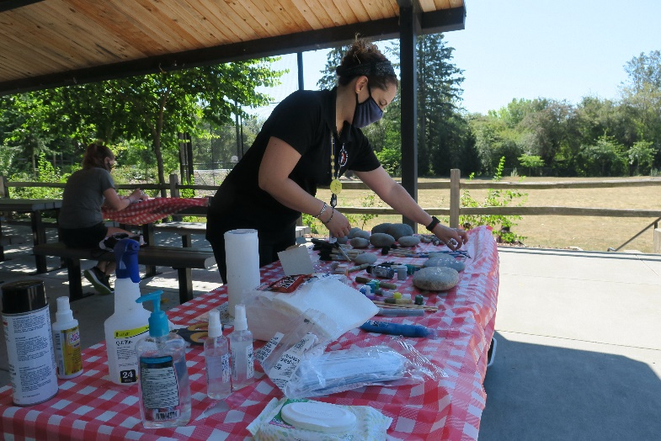
Reinforcing Positive Behaviors
As a RISE Leader, you can encourage good behavior in several positive ways:
- Establish a caring relationship with participants by opening the lines of communication. Learn their name and always show interest in what they are doing and how they are doing. (Avoid nicknames with a negative connotation, even if children use the nickname.)
- Praise participants to encourage positive behavior. Emphasize and reward positive behavior through your speech, facial expression, and action.
- Be consistent and impartial. Give every individual unconditional respect and acceptance. Use eye contact and speak clearly. Be friendly, present, and visible to create an atmosphere of cooperation and fun.
- For every behavior correction, acknowledge one or two appropriate behaviors. Always be fair and enforce behavioral standards consistently, balancing structure with a reasonable amount of freedom.
- A sense of humor is extremely valuable, so use it!
- Every person has needs. Their behavior will give you clues as to what those needs are. If a participant is not engaging in an activity, ask them if they need anything or offer to assist them in getting started.
- If there is an issue, try to see the participant’s side of the situation. Listen to them and seek a staff person to resolve the issue, if necessary.
- When a participant is distracted or acting out, try to redirect them back to the activity at hand or another station at the event. If this doesn’t work, don’t sweat it! It’s likely just time for them to move on to the next activity.
- Remember – Ask for help when you need it!

SAFETY AWARENESS (the 5 P’s)
Preparation – You must plan for activities, situations, and your response.
- Know the procedure in an emergency.
- Be aware of your surroundings.
- Follow the district’s rules and procedures.
- Get to know the people you are working with – learn their names.
Persistence – Welcome patrons and assist them with their needs.
- Be welcoming and inclusive to everyone.
- Keep supplies stocked accessible to participants.
- Keep an eye on the participants at your station and assist where needed.
- Socialize with the program participants.
Partnership – You are not alone!
- Communicate with the staff.
- Know who to find in an emergency.
- Ask for help or clarification.
- Never be alone with a child.
- Be a part of the team.
Practice – You are always working on improving yourself and the program.
- Reinforce respectful behavior among program participants, especially youth.
- Show that you care by listening.
- Encourage everyone to participate.
- Treat everyone fairly.
- Lead by example.
Presence – Be mentally present while you are volunteering!

CLOSING
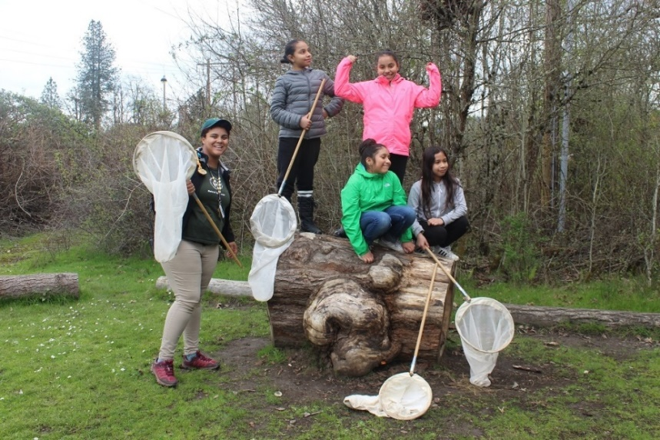
On behalf of our patrons, staff, and everyone at the Tualatin Hills Park & Recreation District, we would like to thank you for stepping up and volunteering as a RISE Leader. We hope you enjoyed your training experience and hope you have tons of fun volunteering this year. While you are out there, we hope you will implement some of the new skills and techniques you learned in training.
Remember – You can always refer to this manual. Staff are there to help you along the way and answer any questions you might have. If you have any comments or concerns about the training or your experience as a volunteer, please contact Melissa Marcum, at (503) 619-3941 or m.marcum@thprd.org. Thanks again and have a great year!

